Minutes of a meeting of Chelsham and Farleigh Parish Council held on 1st June 2026 in Farleigh Hall, Farleigh Court Road at 7.00pm

Present: Cllr Jan Moore (in the Chair) Cllr Linda Fullerton-Batten Cllr Alex Andrews Cllr Chris Deefholts Cllr Jeremy Pursehouse Cllr Cindy Steer Cllr Neil Chambers

In attendance: Samantha Head (Clerk) Cllr Jacquie Thomson (SCC)

And 1 parishioner

The meeting commenced at 7.01pm

- Apologies for absence
None
- Declaration of Disclosable Pecuniary Interest by Councillors of personal pecuniary interests in matters on the agenda, the nature of any interests, and whether the member regards the interest to be prejudicial under the terms of the new Code of Conduct. Anyone with prejudicial interest must, unless an exemption applies, or a dispensation has been issues, withdraw from the meeting.
None
- Public Participation
- Local Plan – at the Warlingham PC APM Nick Perrins, Principal Planner for the new Local Plan at TDC, was the guest speaker. He stated that TDC has to submit the draft LP by 31st December 2026. The concern is the new Unitary Authority will not see it as a priority. There will be a number of public consultations. Junction 6 on the M25 remains an issue, as does building around train stations and planning applications in excess of 150 dwellings (which will be decided by the Secretary of State). TDC is currently working on the HEELA, Green Belt assessment and other assessments. Officers are working through the 2500 comments received relating to the previous plan. Warlingham, in conjunction with Whyteleafe, will be a tier 1 settlement and therefore very unlikely to be classified as Grey Belt. TDC will be looking for Brownfield sites. The Regulation 18 consultation will take place this summer. The draft plan should be ready by autumn. Questions were asked regarding what the fall back option would be if TDC did not meet the deadline and whether the officers working on the plan would be transferring to the new East Surrey Council so that work on the LP can continue after Vesting Day.
- To approve and sign the minutes of the council meeting held on 11th May 2026
0435/0626 Members resolved that the minutes reflected a true and accurate record of the meeting held on 11th May 2026. They were duly signed by the Chair.
- Election of Vice Chairman
0436/0626 Cllr Moore asked for nominations for the office of Vice-Chairman. Cllr Pursehouse nominated Cllr Fullerton-Batten and this was seconded by Cllr Deefholts. There were no other nominations.
- Declaration of Acceptance of Office of Vice Chairman
Cllr Fullerton-Batten signed her declaration of Office of Vice Chairman.
- Officer’s report
- The dual bins have now been installed on Chelsham Common (people were trying to use them before the installation had even been completed). The Clerk has emailed TDC to ask if they can be added to the collection schedule.
- The Clerk has updated the PC’s CIL report and posted it on the PC website.
- Matters arising (for information only)
- Cllr Moore confirmed that the Farleigh Common noticeboard had been repaired and repainted.
- Cllr Moore noted that the smaller wooden bench on Chelsham Common was broken and would be removed the following day.
- Reports:
- County Councillor
The new County Councillor, Jacquie Thomson, introduced herself, saying she was delighted to be representing the area at SCC. She said everyone had been so welcoming.
- District Councillors i) Cllr Jeremy Pursehouse, ii) Cllr Anna Patel, iii) Cllr Perry Chotai
- Cllr Pursehouse noted that the Unitary Authority had 71 councillors at present. There was lots of training. The UA will have £34m of debt from the outset. The UA will be Liberal Democrat controlled. Cllr Pursehouse’s objective was to not let social services, although vital, overawe the other services e.g., roads, fly tipping, planning.
- Cllr Patel had sent her apologies.
- No report.
- Review of Roles and Responsibilities for 2026-27
The PC reviewed the roles and responsibilities:
0437/0626 It was agreed that the following roles would be undertaken by these Parish Councillors:
Representatives on outside bodies:
Cllr Steer – Warlingham Library, Cllr Moore – Charity in Need, Cllr Deefholts – Biggin Hill Airport Committee
Planning Working Group – Cllrs Andrews, Fullerton-Batten, Deefholts, Steer.
Cllr Moore – banking authorisations, green spaces, Chelsham and Farleigh noticeboards
Cllr Fullerton-Batten – banking authorisations, public rights of way / fly tipping, green spaces
Cllr Chambers – AONB
Cllr Pursehouse – green spaces, FaceBook posts
Cllr Steer – green spaces, fundraising & grants
Cllr Andrews – public rights of way / fly tipping, green spaces
Cllr Deefholts – public rights of way / fly tipping, green spaces, CR6 articles
Risk assessments / Annual walkabout – all councillors
- Agree date for Chelsham Common cuts
SCC had cut the sight lines around Chelsham Common. This would be left until later in the year.
- Land North of Chelsham Road application - update
The decision date has been pushed back to 23rd July. No documents have been published since 2nd January 2026.
- Planning – to determine the Parish Council’s position on Appendix A:
TA/2026/303 Land Adjacent to Caravan Site CR6 9QG
Application for the material change of use of land to provide an extension to an existing Gypsy / Traveller site, comprising the stationing of 6 static caravans.
0438/0626 Comment:
This land is also known as ‘Land on the South West side of Hesiers Hill’. It is undeveloped countryside historically used for grazing, which contains priority habitat of deciduous woodland, ancient woodland, ancient pond and grassland. It is in the Green Belt; an Area of Great Landscape Value and Natural England have proposed this site to be included in the extended Surrey Hills ‘National Landscape’.
Unlawful Development This is a retrospective planning application. Trees were felled to create a new access, hardstanding was laid, and additional caravans and associated paraphernalia were brought onto the site. Residents reported more caravans using the access road to TAN08, where four static caravans are permitted under appeal APP/M3645/C/21/3284447 and 3284448 against ENF2019/221. When Tandridge District Council enforcement officers inspected the site in November 2025, they identified this new unauthorised development, known as ‘Hessiers Hill’. Enforcement action (ENF2025/236) was then taken to prevent further works and the introduction of any additional caravans etc.
This is not an extension of the existing site. It is a separate parcel of land, historically comprising field and woodland, purchased by the applicant in 2022 and registered under title number SY449539. Its boundary extends well beyond the 0.23 hectares stated on the application form, raising concerns about future expansion. Previously, there was no access to the proposed site from TAN08.
Breaching planning law should not be rewarded. This is another example of intentional unauthorised development, as shown by the planned ‘As Proposed Site Plan’ J005354-DD-03 Rev B, dated July 2025, and Google Earth imagery indicating that the new site was laid out before 11th August 2025. The applicant therefore incorrectly states that work commenced on 1st October 2025.
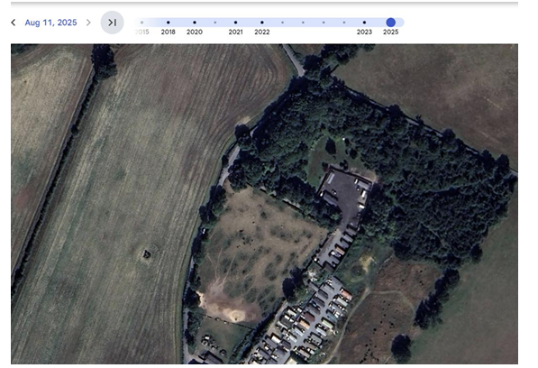
Then followed a planning application 2025/1308 (withdrawn) which was submitted in November 2025 coinciding when enforcement action was taken by the Council.
Not Previously Developed Land (PDL) The applicant states that the land is part PDL but the land has historically been in agricultural use, it therefore cannot be considered as Previously Developed Land as set out in the NPPF. The change of use to residential and all associated paraphernalia together with the introduction of hardstanding, mobile homes and touring caravans and 20 carparking spaces would constitute inappropriate development in the Green Belt which would also be harmful to openness and conflict with the purposes of the Green Belt. No very special circumstances are identified that would clearly outweigh the harm by reason of inappropriateness and other identified harm and, as such, the proposal would be contrary to Policy CSP9 of the Core Strategy, Policies DP10 and DP13 of the Tandridge District Local Plan: Part 2 – Detailed Policies 2014 and the NPPF 2024.
Google imagery shows the site as field and woodland dating back to 1945, while the unauthorised hardstanding was laid in 2025. Point 29 of the Planning Inspector’s report for Appeal A Ref: APP/M3645/C/21/3284447 and Appeal B Ref: APP/M3645/C/21/3284448 (Land adjacent to Caravan Site, Beech Farm Road, Warlingham CR6 9QG (TAN08) further demonstrates that this land is not previously developed land (PDL):
‘Since the previous appeal, the appellant has purchased land to the north of the site (the application site). That parcel of land is substantially larger than the appeal site. While no ecological survey of this land has been carried out, I saw that it contains unmanaged woodland and grassland habitats……’
Area of Great Landscape Value and National Landscape This site and wider area in the ‘Area of Great Landscape Value’ has been identified for many years in successive local plans as having significant landscape value that should be protected. Given its identified landscape sensitivity and contribution to the character of the area, AGLVs perform an important role in ensuring development is sustainable in terms of meeting environmental objectives. AGLV, therefore, retains significant status and any proposals to develop on them are deemed to represent unsustainable development.
On 21st November 2025, Natural England launched the notice period for the Surrey Hills National Landscape Boundary Variation. This site and surrounding landscape have long been viewed as worthy of inclusion in the Surrey Hills. Natural England is of the view that the Beddlestead valley meets the natural beauty criterion and that the extension area called ‘Woldingham Valleys’ should be extended eastwards to also include the Beddlestead Valley and should extend as far as Norheads Lane and Lusted Hall Farm, including the visually important valley slopes which make a contribution to the scenic compositions experienced through the valley system and which are of themselves of high quality. This site has had Natural England’s support for inclusion in the boundary extension since 2024, and the review is now at an advanced stage.
In Natural England’s ‘2025 Desirability Report’, this area contains some of the most intact and dramatic North Downs chalk valley landscapes. Views across valley slopes and along the sinuous valleys, combined with woodland and contrasting open slopes, creates a range of scenic compositions and visual interest which exude drama. The scale of the landscape means that land uses, such as golf courses, remain subservient set within a high quality and visually dominant landscape. This area offers tranquil rural countryside. These areas reflect typical dry chalk valley systems and support notable areas of deciduous woodland and small patches of good quality semi improved grassland.
Since the trees are deciduous and lose their leaves in autumn, the development will be more visually intrusive from the road and public vantage points.
The proposed development would adversely impact upon the character and distinctiveness of a valued landscape as such, the proposed development is contrary to the provisions of NPPF paragraph 187a and 189 and Core Strategy Policies CSP20 and CSP21 and Tandridge Local Plan Part 2: Detailed Policies (2014) policy DP7. 2
Not Grey Belt The site is not Grey Belt as its not PDL and footnote 7 to the NPPF provides a strong reason for refusing or restricting development (i) National Landscapes; (ii) irreplaceable habitats (as demonstrated below).
Green Belt This proposal is inappropriate development in the Green Belt as it has a harmful effect on openness and fails to safeguard the countryside from encroachment. The extension does not conserve and enhance the natural beauty of the soon to be extended National Landscape. There would be an adverse effect on the character and the appearance of this rural landscape. The lack of need for the extension as explained later and the further environmental damage to an area with a priority habitat does not demonstrate the Very Special Circumstances required.
Tree Survey and Biodiversity A tree survey would be required because the site contains deciduous woodland and a parcel of ancient and semi natural woodland, shown in dark green on the Surrey County Council map below, where it borders Chelsham Court Road. This has not been identified in the applicants PEA.
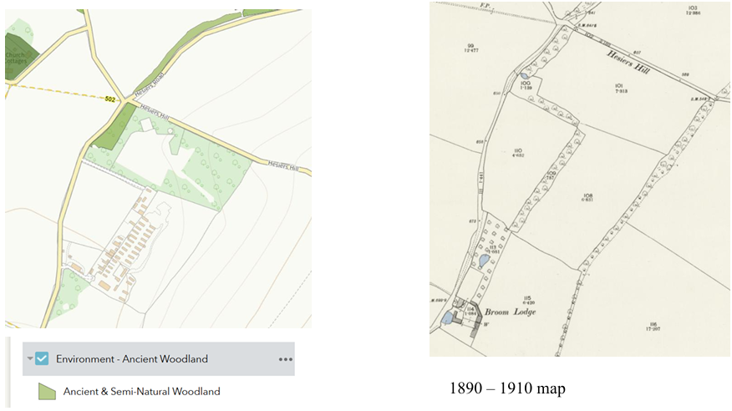
The planning statement says ‘’the application is retrospective in nature, and trees have therefore already been removed. A survey cannot therefore be conducted on the trees contained within the “As Existing” Plans. Their loss has however been accounted for within the ecological work undertaken.’’
The application form says that works started in October 2025, but the ecological appraisal PEA was first dated earlier in 23/06/2025 when the site could have easily had a tree survey at the same time.
The Preliminary Ecological Appraisal is incorrect to state that google imagery only goes back to 2022 as Google Earth can go back as late as 1945. A desk study is not appropriate to analyse this site.
The trees which were felled to make access onto this land, form part of a long-standing tree belt as evidenced by google imagery and historical mapping.
With ancient woodland, grassland, scrub and three ponds in close proximity, we find it hard to believe that the ecology of this site is low as priority habitats have a high biodiversity value. This site is not suitable for any form of development.
The Tandridge District Core Strategy (2008) includes Policy CSP 17: Biodiversity, which provides that development proposals should protect biodiversity and provide for the maintenance, enhancement, restoration and, if possible, expansion of biodiversity, by aiming to restore or create suitable semi-natural habitats and ecological networks to sustain wildlife in accordance with the aims of the Surrey Biodiversity Action Plan.
Surrey County Council adopted the ‘Local Nature Recovery Strategy’ in March 2026. Their map shows the ancient woodland in green is ‘Area of Particular importance for biodiversity’ and an irreplaceable habitat. The area in purple shows ‘Areas that could become of particular importance for biodiversity’ as it is semi-natural woodland.
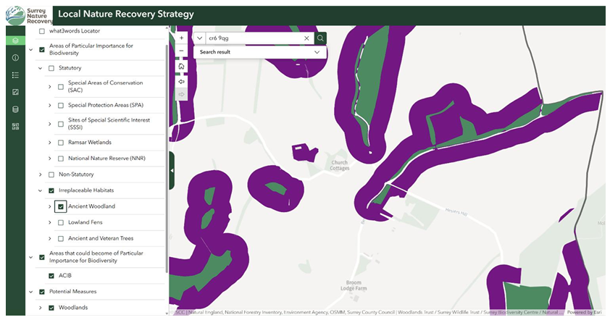
Within the document the policies related to the site are:-
W1.1 Improve the management of existing semi natural woodland to support biodiversity W2.1 Purple area act as a buffer and better connectivity to ancient semi-natural woodland.
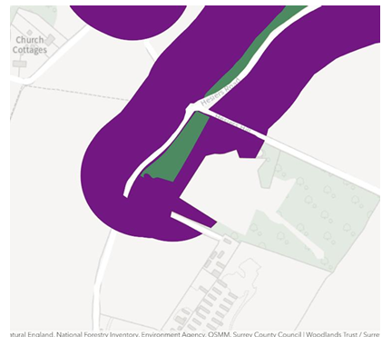
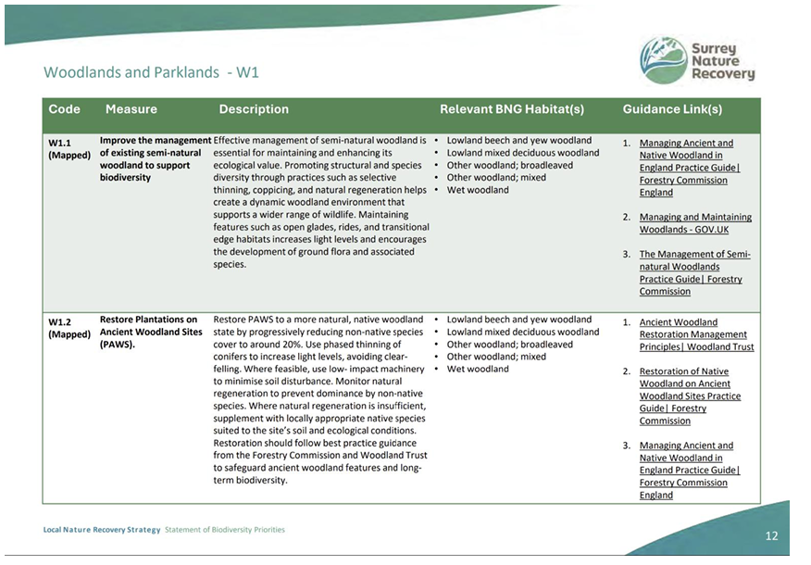
Within Appeal A Ref: APP/M3645/C/21/3284447 and Appeal B Ref: APP/M3645/C/21/3284448 Land adjacent to Caravan Site, Beech Farm Road, Warlingham CR6 9QG Point 29 of Planning Inspectors report stated:-
Since the previous appeal, the appellant has purchased land to the north of the site (the application site). That parcel of land is substantially larger than the appeal site. While no ecological survey of this land has been carried out, I saw that it contains unmanaged woodland and grassland habitats. In addition to the landscape enhancements in the appeal site, the appellant proposes to carry out native broadleaf tree planting, wildlife meadow planting, provision of deadwood piles, open glades, and bird and bat boxes on this additional parcel of land. While details of species, size at time of planting, densities, number and location of bird and bat boxes are not provided, it would not be unusual for these details to be secured through condition. While the land to the north is outside the land identified in the notice, conditions can relate to works on land in the appellant’s ownership, as is the case here.
The planning inspector set a strict timetable for compliance because permission was being granted retrospectively.
Condition 10:-
The use hereby permitted shall cease and all caravans, structures, equipment and materials brought on to the site for the purposes of such use and the hardstanding shall be removed within 30 days of the date of failure to meet one of the requirements set out in (i) to (iv) below: (i) Within 3 months of the date of this decision a scheme to achieve measurable biodiversity net gain of at least 10% and mitigation including a timetable for implementation, monitoring and management shall have been submitted for the written approval of the local planning authority.
The biodiversity requirements were not met within the three-month period. This is not the first time the Brien family has cleared important trees to accommodate caravans, as occurred to make way for caravans 9 to 12 on TAN08. Such tree clearance is unacceptable, and although the applicant suggests biodiversity measures could be 5 secured by condition for this application we do not accept that the applicant would comply with the offer as stated in the Planning Statement ‘Within three months of the date of this decision, an ecological enhancement plan shall be submitted to and approved in writing by the Local Planning Authority……’
The fact that the Brien’s have never complied with biodiversity conditions the planning inspector in Appeal A Ref: APP/M3645/C/21/3284447 stated that noncompliance meant they should no longer be occupying TAN08, let alone be granted this proposed ‘extension’. It appears the applicant is trying to avoid environmental duties.
This retrospective and intentional development has resulted in the loss of woodland habitat and had an adverse impact on biodiversity, and the application does not include details of measures to mitigate this harm. This is contrary to the NPPF 2024 on conservation and enhancement of biodiversity, Policies CSP17 and CSP18 of the Tandridge Core Strategy 2008, and Policies DP7 and DP19 of the Tandridge Local Plan: Part 2 - Detailed Policies 2014.
It is contrary to the recently adopted Surrey County Council ‘Local Nature Recovery Strategy’ March 2026
History of the Brien The Brien’s already have two sites within the immediate area ‘Field 2472’ also known as TAN09 for continued use of land as private caravan site for gypsies for 4 caravans which was granted at appeal but with conditions under (TA/96/P/1052).
• Condition 1: The use hereby permitted shall ensure for the benefit of Mr P Brien, his family and 3 families related to Mr Brien only, and shall comprise no more than 4 gypsy caravan pitches, each containing not more than one residential caravan/mobile home and one touring caravan. When the site ceases to be occupied by Mr Brien or his relations, the use shall cease and all structures, materials and equipment shall be removed and the land restored in accordance with a scheme of works to be submitted to and approved in writing by the local planning authority.
Within the list of appearances at the inquiry this condition relates to the appellant
▪ Mr Patrick Brien
▪ M Brien (Wife)
▪ M Brien (Mother of Patrick)
▪ P Harty (brother-in-law)
▪ Mrs A Harty (sister of Appellant)
We understand that a recent site inspection found the occupants were not those granted personal permission, did not have Traveller status, and that several unauthorised caravans are stationed to the north of the site on land owned by the Brien family.
Then TAN08, Land adjacent to Caravan site, permitted under Appeal A: APP/M3645/C/21/3284447 & Appeal B: 3284448 against ENF2019/221 for 4 pitches
The Appeal listed several conditions or removal of caravans etc within the Planning Inspectors: report-
• Point 64 a personal condition is required.
• Point 65 a condition limiting the number of caravans stationed is needed to protect the character and appearance of the area. In the interests of openness of the Green Belt, only single unit caravans should be permitted. Conditions limiting the size of vehicles parked and preventing commercial activity on the site are with a strict timetable for compliance because permission is being granted retrospectively. (Only 4 pitches granted known as Caravans 9-12).
• Condition 2. The occupation of the site hereby permitted shall be carried on only by the following and their resident dependants:
▪ Mr John Brien (senior) and Mrs Elizabeth Brien
▪ Mr John Brien (junior) and Mrs Ann Brien
▪ Ms Mary Brien and Mr Michael Casey
▪ Mr Tom Brien and Ms Teresa Collins
▪ Mr Patrick Brien
The enforcement visit for ENF2025/236 (Appendix 1) indicates that individuals highlighted in yellow were occupying caravans 1 and 3 on Hessiers Hill. This suggests a breach of Condition 2 of the appeal, as they should have been occupying caravans 9 and 11. As they already have permitted personal plots, no additional pitches are required. The visit also recorded caravan 9 as occupied by Bill Connors and Mary Ellen Collins, and caravan 11 by Elizabeth Brien and Jim Connors, none of whom have a legal right to reside there.
• Point 65. A condition limiting the number of caravans stationed is needed to protect the character and appearance of the area. In the interests of openness of the Green Belt, only single unit caravans should be permitted. Conditions limiting the size of vehicles parked and preventing commercial activity on the site are required in the interests of helping to safeguard the character and appearance of the area and the living conditions of adjacent residents.
• Condition 3 states:- ‘No more than EIGHT caravans, as defined in the Caravan Sites and Control of Development Act 1960 and the Caravan Sites Act 1968 as amended (of which no more than FOUR shall be a static caravan) shall be stationed on the site at any time.’ The enforcement visit (ENF/2025/236) found two further caravans no’s 7 and 8 on TAN08. The site plan submitted with this planning application ‘J005354-DD-03 Rev B’ shows a 5th caravan on TAN08 which is unauthorised, breaks condition 3 of 11th May 2023, Appeal A Ref: APP/M3645/C/21/3284447 and is subject to the high court injunction (ENF2025/236) from January 2026 point 1c.
‘’station on the Land or leave on the Land any further caravans, mobile home, motor home, portacabin or similar accommodation for the purposes of human habitation or residential occupation or for any other purpose in breach of planning control; save that nothing in this Order shall prohibit the occupation of the Land marked with a green outline on the plan attached at Annex 1 of this Order by the persons specified in ‘Appeal A Schedule of Conditions’ in the decision letter dated 11 May 2023 Appeal A Ref: APP/M3645/C/21/3284447 Land adjacent to Caravan Site, Beech Farm Road, Warlingham CR6 9QG (the ‘Decision Letter’) in so far as their occupation is consistent with the ‘Appeal A Schedule of Conditions’ and Decision Letter.’’
Conclusion Chelsham and Farleigh Parish Council strongly objects to this development because of its harmful effects on the Green Belt, the character of the landscape, the intrinsic value of the countryside, and the visual amenity of the surrounding AGLV and National Landscape. It would result in a net loss of biodiversity, environmental harm, and would reward deliberate unauthorised development. The proposed material change of use and associated works have an urban form and appearance that are out of keeping with the rural landscape and countryside setting. The proposal would therefore harm the landscape and the intrinsic character, beauty and tranquillity of the countryside. The concentration of sites in this rural area is already excessive, and we respectfully request that the application be refused. The applicant has not demonstrated any need for an ‘extension’, particularly given the serious occupation and compliance issues at TAN08 and TAN09, where permissions are personal and conditions have not been met. In addition, the Council’s GTAA shows that it can demonstrate a five-year supply of gypsy and traveller sites.
If the planning officer wishes to approve this planning application, we request that it goes to the Planning Committee.
APPENDIX 1 ENF2025/236
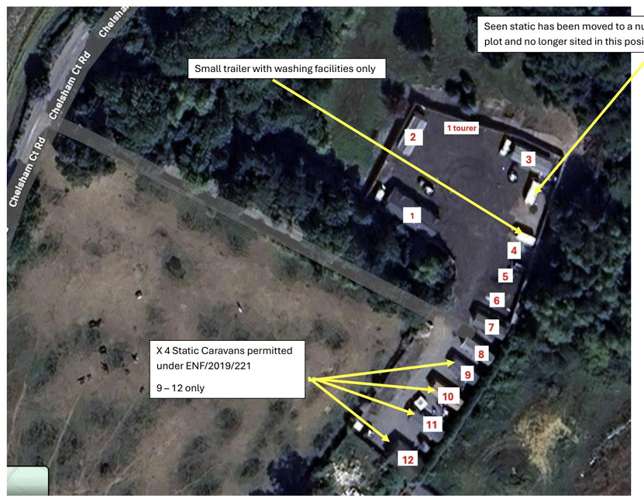
Carvan # 1 occupied by Mr John Brien and wife Ann Brien and x4 children
Carvan # 2 occupied by Mr Patrick Brien and wife Ellen Brien and x2 children
Carvan # 3 occupied by Mr Tom Brien and partner Treasea Collins and x3 children
Carvan # 4 occupied by Ms Ann Marie Collins and husband (name not taken) and x1 child Carvan # 5 occupied by Ms Maureen Brien and husband Martin Brien and no children Carvan # 6 occupied by Mr Bill Brien and wife Marie Brien and x2 children
Carvan # 7 occupied by Ms Mary Cash and no children
Carvan # 8 occupied by Ms Margreat Brien and husband Patrick Brien and no children Carvan # 9 occupied by Mr Bill Connors and partner Mary Ellen Collins and x3 children Carvan # 10 occupied by Ms Mary Brien and husband Micheal Cassey and x3 children Carvan # 11 occupied by Ms Elizabeth Brien and partner Jim Conners and no children Carvan # 12 occupied by Mr John Brien Senior and wife Elizabeth Brien and no children living with them.
TA/2026/364 9 East Parkside, Chelsham, Warlingham CR6 9PY
Erection of a single storey garden building within the rear private amenity space, to accommodate a gym. The proposal will have overall dimensions of 7.5m in width, 4m in depth and 2.8m in height.
0439/0626 Comment: Chelsham and Farleigh Parish Council has no objections to this application.
TA/2025/525/Cond1 Land at Beech Farm Road, Warlingham CR6 9QT
Details pursuant to the discharge of Condition 2 (Site Development Scheme) of planning permission ref: 2025/525 dated 16/02/2026 (Extension of existing traveller site and associated change of use of land to form 5no. additional pitches, each comprising the siting of 1no. mobile home and 1no. touring caravan and the erection of 1no. dayroom, alongside formation of new site access and amendments to existing pitches to facilitate revised layout).
0440/0626 Comment: Chelsham and Farleigh Parish Council maintains its previous position and objects to any further development at this site.
- Finance
- Items for expenditure
- Earth Anchors Ltd – picnic bench – price tbc
0441/0626 Members agreed to purchase x2 2m Surrey benches and required fixings, as well as the bases.
- Receive and Accept Year End Internal Audit report and recommendations
0442/0626 Members received the Internal Audit report. There were no recommendations.
- Annual Governance and Accountability Return – Approval of Annual Governance Statement for AGAR 2025-26
0443/0626 It was resolved to approve the Annual Governance Statements for the 2025-26 Annual Governance and Accountability Return (AGAR). All boxes were ticked as appropriate and the AGAR was signed, as indicated by the Chairman and the Clerk.
- Annual Governance and Accountability Return – Approval of Annual Accounts and Annual Return for 2025-26
0444/0626 It was resolved to approve the Annual Accounts for the 2025-26 Annual Governance and Accountability Return (AGAR). The AGAR was signed and dated by the Chairman.
- Appoint Internal Auditor for 2026-27
0445/0626 Members approved the appointment of Mike Platten, April Skies Accounting, to be the Parish Council’s Internal Auditor for 2026-27.
- Receive monthly bank reconciliations – to be signed by two councillors
These will be provided at the July meeting.
- Receive monthly budget v actual Year to Date report
This will be provided at the July meeting.
- Payment of invoices:
Samantha Head Salary- May £ 456.00
April Skies Accounting Year End Audit Fee £ 160.00
Lloyds Bank Fees – April £ 4.25*
Tony Norris Ditch clearing and pond debris £ 60.00
*already paid by DD
0446/0626 Members approved the payments.
- Meetings and Correspondence
None
- Matters for reporting or inclusion in a Future Agenda or Reports for Facebook or press
- Tree on Bull Green (Oak) – looking in poor condition

The meeting closed at 8.40pm

The next Parish Council meeting would be held on 6th July 2026 at 7pm.
The next Planning Working Group meeting would be held on 29th June.

