Minutes of a meeting of Chelsham and Farleigh Parish Council held on 6th October 2025 in Farleigh Hall, Farleigh Court Road at 7.00pm

Present: Cllr Jan Moore (in the Chair) Cllr Jeremy Pursehouse Cllr Chris Deefholts Cllr Neil Chambers (at 7.02 pm) Cllr Cindy Steer (after item 5)

In attendance: Samantha Head (Clerk)

And 1 parishioner
The meeting commenced at 7.00pm

- Apologies for absence
0320/1025 Cllr Fullerton-Batten and Cllr Andrews had sent their apologies. These were received and accepted by members.
- Declaration of Disclosable Pecuniary Interest by Councillors of personal pecuniary interests in matters on the agenda, the nature of any interests, and whether the member regards the interest to be prejudicial under the terms of the new Code of Conduct. Anyone with prejudicial interest must, unless an exemption applies, or a dispensation has been issues, withdraw from the meeting.
None
- Public participation
None
- To approve and sign the minutes of the previous council meeting held on 1st September 2025
0321/1025 Members resolved that the minutes reflected a true and accurate record of
the meeting held on 1st September 2025. They were duly signed by the Chair.
- Co-option of new Parish Councillor
The Chairman noted that, after advertising the casual vacancy, two candidates had come forward. One candidate had since then withdrawn their application. Cllr Moore introduced the remaining candidate, Cindy Steer. Cindy Steer had sent in a written application, which had been circulated to members on receipt, and she felt there was no further information to add. Cllr Moore offered members the opportunity to ask questions.
0322/1025 The Chairman proposed Cindy Steer be co-opted on to the Parish Council and it was resolved to accept this by unanimous vote (show of hands). Cindy Steer signed her Declaration of Acceptance of Office and took her place at the council table and participated in the remainder of the meeting. The Chairman and other councillors welcomed her to the Parish Council.
- Officer’s report
- The Clerk reported that TDC had now received the 3rd and final CIL payment in respect of Chelsham Heights. £1262.86 would be paid to the PC by the end of April 2026.
- The Clerk noted that she had just this afternoon been invited to a training session on injunctions, stop notices and court orders in planning with Caroline Bolton, a barrister at Radcliffe Chambers, which would take place on Wednesday 8th October. The Clerk reported that due to the short notice, she would be unable to attend and had sent her apologies. She had also asked to be sent the recording and meeting notes and had asked if the invitation would be extended to Parish Councillors.
- Matters arising (for information only)
None
- Reports:
- County Councillor
None
- District Councillors i) Jeremy Pursehouse, ii) Anna Patel, iii) Perry Chotai
- Cllr Pursehouse reported that TDC’s Housing Department had received a very poor report from the inspector. It had been graded C4 – the lowest rating. There would now be regular meetings between the inspectors and TDC officers. The positive news was that the housing was regarded as good, it was the systems that required work. One of the areas highlighted was that TDC officers were solving problems / complaints from residents themselves but not keeping the correct records of these complaints and the actions. Jane Rochelle is the new Head of Housing.
TDC is preparing a new Local Plan. This is a central Government requirement. At present, TDC is at the stage of agreeing policies, which also include the new planning laws regarding Green Belt / Grey Belt. Submissions for the new HELAA are open. Cllr Pursehouse confirmed that Land North of Chelsham Road, Greenacres and Kennel Hall Farm had all been submitted, as well as Pony Meadow and some Biodiversity sites. There are public consultations, and this was the time for residents to air their views.
It was noted that the criteria regarding Green Belt protection applied to historical towns and only one was listed in Tandridge (Oxted).
Councillors asked questions on how TDC funds its housing stock and why TDC was persisting with a new Local Plan as the council would only exist until the end of April 2027.
- Cllr Patel had sent her apologies. There was no report.
- Cllr Chotai had sent his apologies. There was no report.
- Save Warlingham’s Green Belt – letter to TDC
At the PC’s September meeting, it was reported that Save Warlingham’s Green Belt has written to TDC regarding planning concerns. The PC was copied in on this letter when it was sent. Since then, TDC had responded (on 5th September) and SWGB had further replied on 25th September. The TDC response was circulated to the PC. SWGB copied the PC in on its reply.
- External Audit 2024-25
The Clerk had circulated the external auditor’s report to all councillors. There were no matters raised. The Clerk has published all required documents on the Parish Council’s website ahead of the deadline of 30th September.
- Correspondence from DAC Beachcroft re Insurance Claim
This is ongoing and there is no tangible update. The Parish Council is still seeking a copy of the loss adjuster’s report and breakdown of costs.
- Meeting venue for PC meetings 2026
An opportunity has arisen for the Parish Council to relocate to a different meeting venue at Warlingham Bowls Club. The venue has ample car parking, kitchen facilities, heating and external lights. The proposed cost is £250 per year for 11x meetings and the APM. The Chairman has circulated photographs of the facilities to all members. The current venue in the hall at St. Mary’s Church is paid up until the end of 2025.
0323/1025 Members agreed to move venues from January 2026. The clerk to arrange a new long-term contract and write to advise St Mary’s Church.
- Lad North of Chelsham Road application - update
Following requests for an update from the PC via Cllr Pursehouse, it was advised that the consultation is being re-run due to the submission of further details. The planning officer noted that if she were minded to approve, the application would go to Planning Committee for a decision in November or December.
The Parish Council contacted its planning consultant regarding the additional submissions from the applicant. He felt that there was no need for a ‘fuller’ response but submission of a comment making it clear that the PC maintains its objection to the application and that it does not view the whole area as grey belt and it therefore remains inappropriate development and should be refused.
0324/1025 Members agreed and approved the submission of the following comment:
Chelsham and Farleigh Parish Council have reviewed the latest documents submitted by Montagu Evans. Our objection to the application remains unchanged. We do not consider the entire site area to be within the ‘grey belt’ designation, as the northern portion of Greenhill Lane does not meet the criteria and consequently remains inappropriate development within the Green Belt. Importantly, the development of these plots would see a tier 1 settlement spreading towards adjacent open Green Belt in an entirely rural area. This would be contrary to the government's recent advice regarding Green Belt protection, which states that towns should not be allowed to encroach on neighbouring Green Belt, and so for this reason the application to expand Warlingham towards Chelsham should be denied.
On Wednesday 10th January 2024, Chelsham and Farleigh Parish Council attended a presentation with Welbeck along with Warlingham Parish Council. The proposal submitted has not undergone any modifications since the woodland was reclassified as ‘lowland mixed deciduous woodland, a Habitat of Principal Importance’. We do not believe that the retention of this HPI woodland has been a key consideration, as the linear park has always been part of the proposed development along with the desire to develop the rest of Kennel Farm Field.
We have substantial concerns regarding the appropriateness of a linear park within the AGLV, the harm to the skylarks that nest on Kennel Farm Field and the deliverability of the linear park due to no details of cost, design, the types of trees and plants that would be required, and the maintenance requirements.
Furthermore, we believe that the applicant has not demonstrated a compelling need for a care home. With no established care model or provider, or consultation with Surrey County Council or Croydon Council, who are responsible for overseeing the Adult Care Strategy.

The site makes a strong contribution to openness, both spacial and visual, and the Green Belt purposes of checking the unrestricted sprawl of large built-up areas and safeguarding the countryside from encroachment as well as being Grade 3 agricultural land. Any development would be clearly visible from Chelsham Road and the ridge at the top of Kennel Farm, thereby impacting on the openness and permanence of the surrounding Green Belt. That openness will be lost to accommodate over development with a linear park including "small urban trees" (Ecology Solutions assessment) which are unlikely to be cared for and grow. The site is not in a sustainable location, is not served by adequate public transport and will add to the bottlenecks at Warlingham Green and junction 6 of the M25 on its own account and when added to the developments already approved in Warlingham. The truth is that the only basis on which the developer might overcome the obvious conclusion that the benefits of the scheme do not clearly outweigh the Green Belt and other harm is the figleaf that part of the development is proposed in an area allocated in the defunct local plan. However:

- The allocations in the local plan concentrated in the north of the district and a number have already gone forward but due to the passage of time an assessment of Warlingham's ability to take yet more, should be under consideration by TDC at a strategic level.
- The proposed overdevelopment bears no relationship with that considered in the local plan.
- The local plan recognised that the site south of Greenhill Lane is ecologically sensitive and in part defined as ecologically unsuitable where it is now proposed to build houses, that north of Greenhill Lane was assessed as not suitable for development yet the application maintains the same proposal for that area as was put forward for the local plan.
- C&F PC – potential transfer of TDC Community Assets
Following the agreement at last month’s meeting, Cllr Pursehouse chased TDC regarding the questions it had been asking for several months in relation to Little Farleigh Green. The PC was keen to have this information in order to better understand its commitment and liabilities if it were to take on this asset. These include but are not limited to: additional cost in the tree survey, additional tree work, grass cutting, possible new access gate and lock, new signpost (and installation), general rubbish and dog poo bin collections, the management of the undergrowth (brambles / bracken) which has not been done for a number of years, maintenance of the pond and the potential legal issues (parking on the common and a waste pipe coming from private land). After further prompting, TDC responded to say that the pond and its environs would need to be considered once the PC had taken ownership of the asset, the gate / signpost / boundary fence could be replaced and the PC could present an invoice for payment to the district council, the legal issues would need to be considered and the waste pipe was a matter for Environmental Health. All these could be raised by the PC’s solicitor and included in the initial Heads of Terms document.
It was noted that the minimum solicitor’s fee for the PC would be £1500. TDC has asked for solicitor’s details by 17th October.
Cllr Chambers suggested one solution would be to get quotes for an all-inclusive contract and ask TDC to pay it. He asked if TDC would be offering these assets to any other groups.
Cllr Pursehouse said that the legal issues would need to be resolved before the PC took over the asset. In his mind, the risk to the PC was high and there was potentially too much work for the PC.
Cllr Deefholts stated that when this was first raised, his instinct was to take over the 3x TDC assets in the parish. However, having now walked the parcels of land and having a better understanding of the scope of work and the financial burden, he had changed his mind and felt it would be unwise to take any on.
Cllr Moore said that she did not feel it would be a good idea for the PC to take on LFG.
Cllr Steer said that she did not know enough of the details but, based on the information she had heard this evening, she felt it would not be in the PC’s best interests to take this asset on.
0325/1025 Members agreed not to take on Little Farleigh Green. It was further agreed that the PC should highlight the legal concerns and possible environmental health issues to TDC.
- Planning – to determine the Parish Council’s position on Appendix A:
TA/2025/638 1a Worms Heath Cottages, Limpsfield Road, Warlingham CR6 9QL
Single storey side and rear extension to the dwelling.
0326/1025 Comment: Objection

The application is in the Parish of Chelsham, in the Green Belt, an Area of Great Landscape Value and within the proposed extension to the Surrey Hills National Landscape.

To evaluate this application the history of no. 1 and no.1a Worms Heath Cottages must be considered: -

- 89/435 – No.1 Worms Heath Cottages. Erection of detached double garage to the front of the dwelling and formation of new access track – Approved 13/06/1989

- 92/56 - No.1 Worms Heath Cottages. Erection of a single storey side extension to provide a dining room- refused.

- 2001/1721 no.1 Worms Heath for demolition of existing lobby and erection of single/two storey side extension and first floor rear extension -refused and dismissed at Appeal Ref: APP/M3645/A/02/1086743.

- 2002/1443 – no.1 Worms Heath - Erection of carport, log shed, and boat shed together with porch link between garage and outbuilding – Certificate of Lawfulness for Existing Development granted 11/11/2002
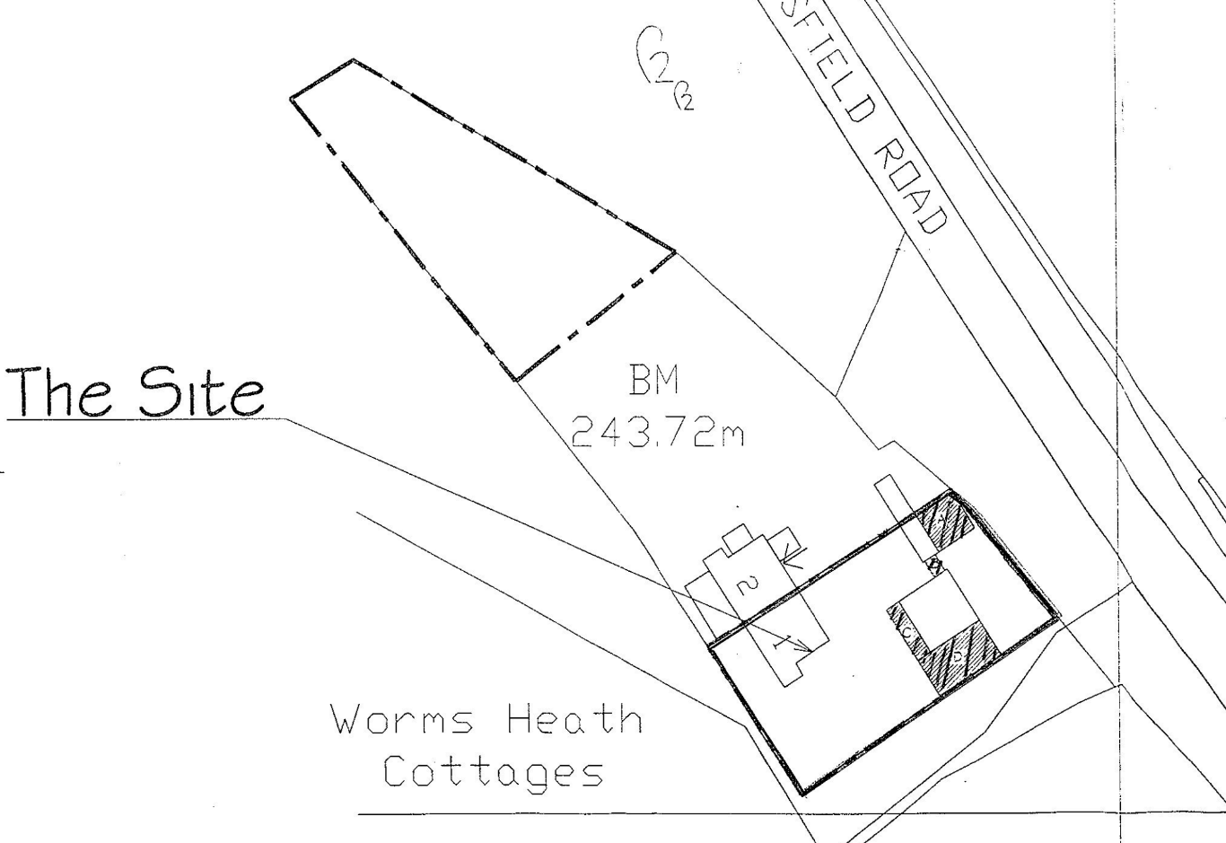
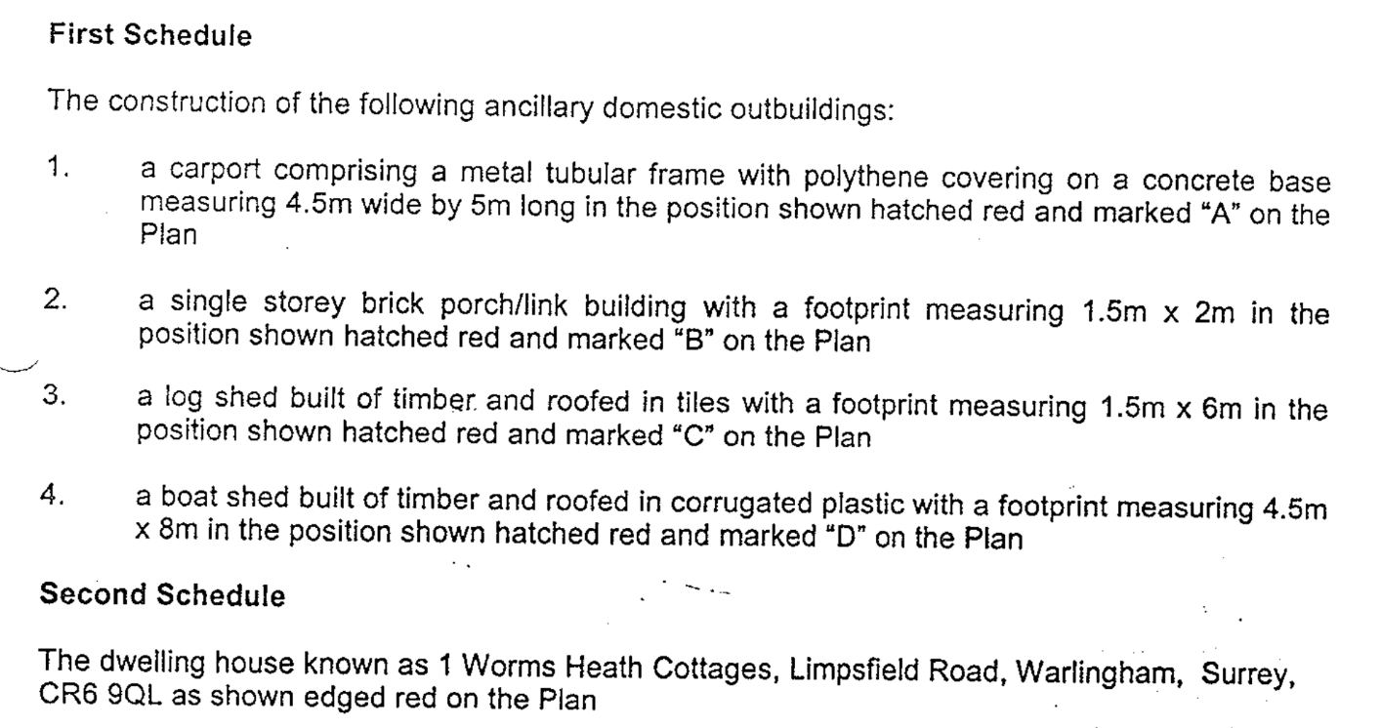

- The carport metal frame is still present but not the polythene covering or concrete base.
- appears to still exist
- The log shed has been absorbed into no.1a
- The boat shed demolished.

- 2021/1364 no.1a Worms Heath - Continued use of outbuilding as a dwelling (Class C3). (Certificate of Lawfulness for Existing Use or Development) Ward: Warlingham East and Chelsham and Farleigh – refused.

- 2022/660 no.1a Worms Heath - Use of garage/outbuilding as separate, self-contained dwelling (Application for a Certificate of Lawful Development for an Existing Use or Development) allowed.

Within application 2022/660 the officer report states:-

‘’ENF/2021/198 which relates to “garage converted to dwelling”, subject of this application and which remains open. Previously, the building was also investigated by Planning Enforcement under reference ENF/2007/307. Under this case, there is a letter from the Council setting out the informal officer view that provided the garage, (subject of this application) which was built under planning permission 89/435, used for additional habitable accommodation remains and is used ancillary to the enjoyment of the main dwelling then it would not require planning permission. In that letter from the Council it states, “Next to the boat shed is a garage…”. As such, in relation to the Council Tax name of the property on file called “The Boat Shed”, it is understood that this was a mistake as the Boat Shed was previously demolished. It is accepted that Council Tax payments are in relation to the ‘garage conversion’ and not the ‘Boat Shed’.’

No.1 Worms Heath Cottage appears to have undergone additions since 2002. The plan submitted for 2022/660 indicates extensions to the side, front, and rear garden outbuilding. Then in front of these cottages is common land, and we have observed that the applicants have enclosed this space by constructing a wall along the frontage of Limpsfield Road and created a larger parking area which is not within their title deeds. The wall should be removed and the grass common restored.
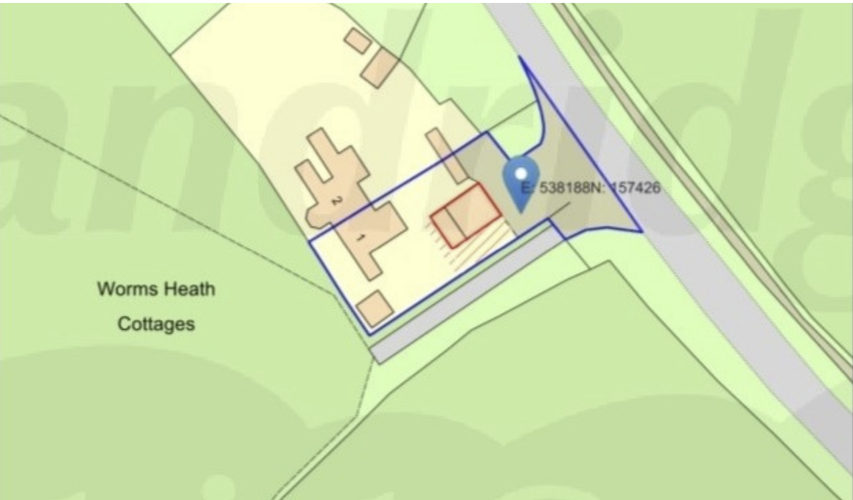

No.1a Worms Heath originates from the garage of No.1, constructed in 1989 and the later built log shed. These outbuildings were not part of the original house, which predates 1948.
Planning application 2001/1721, Appeal Ref: APP/M3645/A/02/1086743, states that No.1 Worms Heath Cottages underwent an extension in the 1960s, comprising a single-storey, flat-roofed kitchen extension of approximately 3.24 square metres. This is supported in planning application 2014/1519 for No.2 Worms Heath, where the officers report mentions a kitchen extension being constructed (at both properties) around 1962. The original cottage, No.2 Worms Heath, was measured at approximately 318m³. It is reasonable to assume that No.1 Worms Heath Cottage would have been originally of a comparable size. In 2022, the garage, known as No.1a Worms Heath, was granted a ‘Certificate of Lawful Development for an Existing Use or Development’ as a separate dwelling.
The Council’s guideline suggests that a 40% increase in the volume of the dwelling from its original size would be acceptable within the green belt. However, the proposed extension to No.1a Worms Heath constitutes a 66.18% increase, leading to a significant impact. Furthermore, considering that the curtilage of No.1 Worms Heath has already been subdivided to create two dwellings, further extensions would result in more sporadic and incremental enlargement of dwellings within the green belt, which should be resisted.
The reason for the proposed extension is acknowledged, but personal requirements of occupants may change over time or cease entirely, leaving lasting harm from inappropriate development.
The proposal fails to comply with DP13 of the Local Plan, particularly section E, as the extension and alterations in the Green Belt will result in disproportionate increase over the original building’s size as it existed on 31 December 1968 or, if constructed after 1968, as it was built originally. Additionally, it does not comply with NPPF 2024, para. 154c, as it is a disproportionate addition over the original building’s size. The Framework defines the date of an ‘original building’ as 1st July 1948, or as originally built if constructed after that date.
The proposal would substantially increase the width of its frontage, adding a front door and window. Whilst its single storey, it would be an elongated form which would mean development is extended more or less the full width of the plot and would be a block of build form disproportionately wide compared to the original house. This is overdevelopment, out of character, and of poor design in the AGLV and national landscape. The site is highly visible from Limpsfield Road and footpaths ’16’ and ‘16a,’ which are adjacent to No.1 Worms Heath Cottages.
Should permission be granted, we request the removal of permitted development rights to prevent further disproportionate enlargements.

TA/2025/1004 Nore Hill House, Barnard Road, Warlingham CR6 9QE
Erection of extensions at ground and first floor level together with associated elevational alterations.
0327/1025 Comment: Past applications:-
- GOR/509/72 Adj Nore Hill House, Barnard Road, Chelsham Two bungalows on approx. 0.13 Acre & 0.2 Acre respectively – refused in 1972.

- 92/629 Erection of a single storey side extension to provide a double garage and utility room with a single storey rear extension to provide a sun-room with a balcony over.

The site is in the Green Belt, Area of Great Landscape Value, Biodiversity Opportunity Area, set in Ancient woodland and in the proposed Surrey Hills National Landscape. The dwelling is an attractive character property set in a rural landscape with footpath 16a which runs next to the boundary.

The Council’s guideline suggests that a 40% increase in the volume of the dwelling from its original size would be acceptable within the green belt. The house was built between 1937 and 1958. The council and NPPF supports extensions in the green belt within Policy DP13 of the Local Plan, where extensions E states where the proposal does not result in disproportionate additions over and above the size of the original building as it existed at 1 July 1948 (for non-residential buildings) or 31 December 1968 (for residential dwellings), or if constructed after the relevant date, as it was built originally. The NPPF 2024, para. 154c, defines the date of an ‘original building’ as 1st July 1948, or as originally built if constructed after that date.

The land registry map is from 1958 and when compared with the existing site block:-
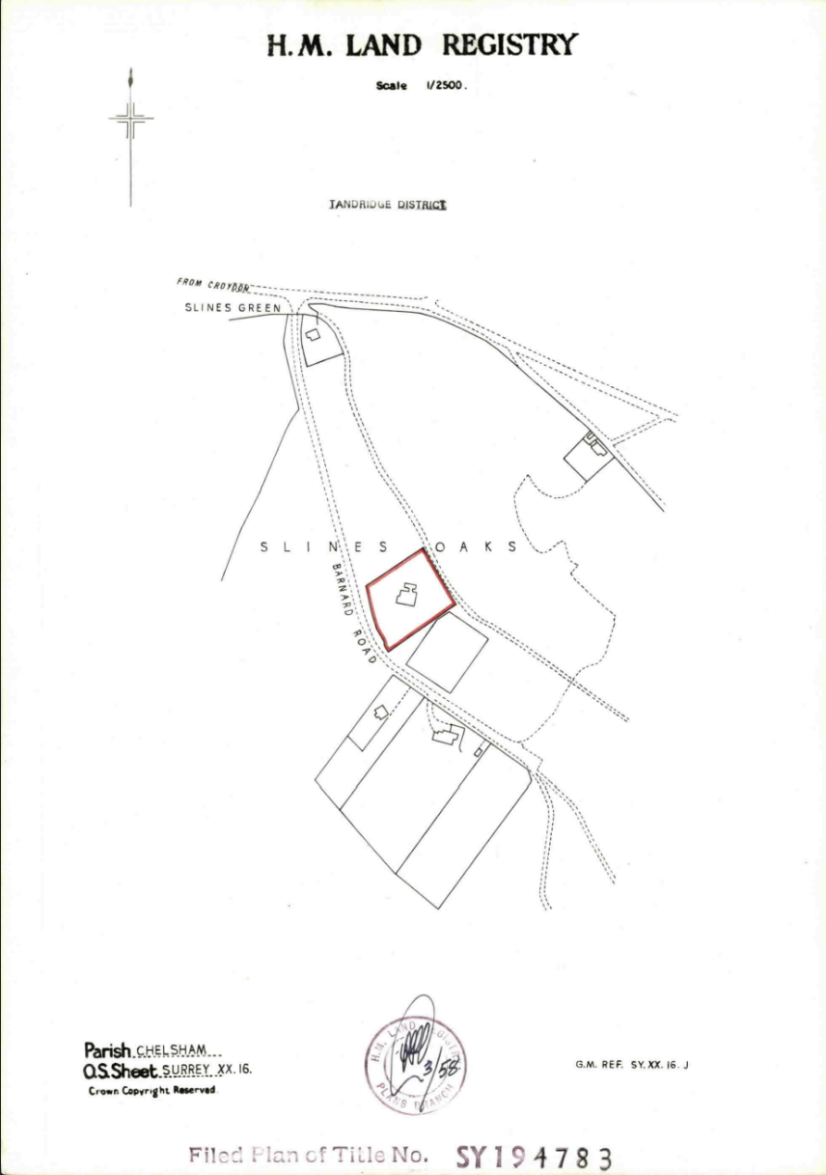
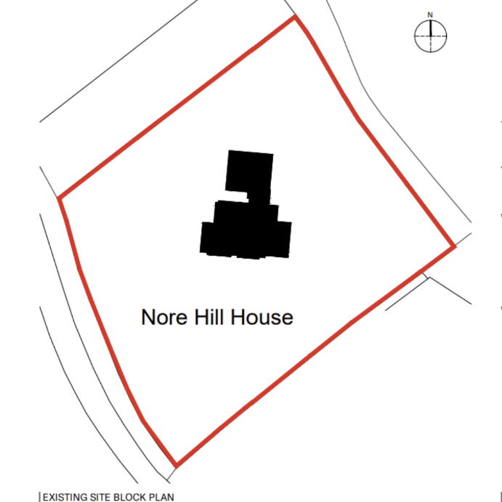
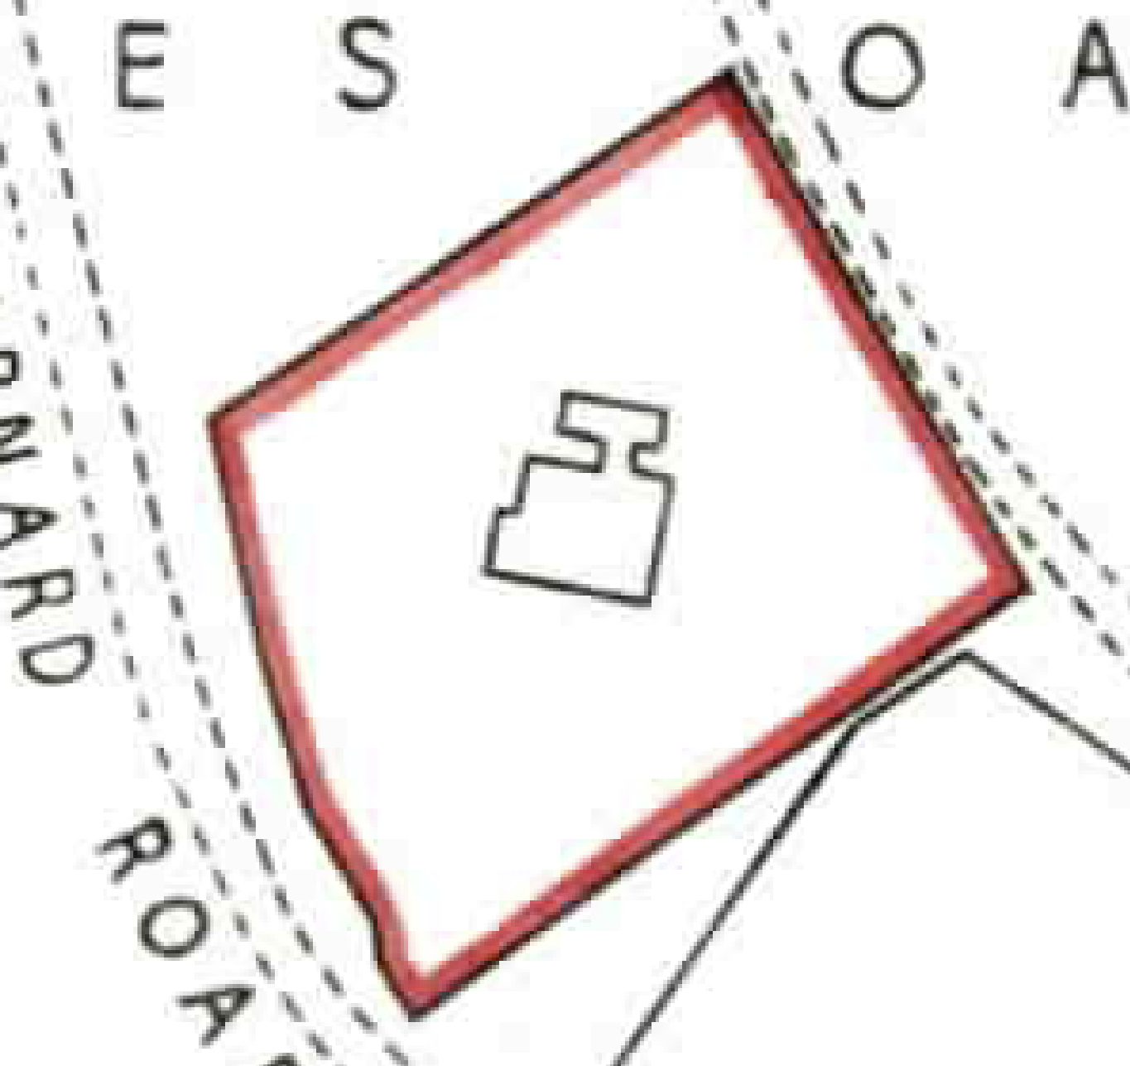

The additions from the planning application 92/629 are evident.

The Planning, Design and Access Statement states the proposed extensions would mean the dwelling would be 1255.5m3 however the original dwelling was not 983.2m3 in 1958, this volume is the current dwelling, which would include the 1992 additions. The Parish Council does not object to this application provided that it remains within the 40% additional volume and will not harm the national landscape designation or Area of Great Landscape Value, Biodiversity Opportunity Area, or Ancient woodland.

TA/2025/1039/TPO Land at Great Park, Warlingham CR6 9PU
Trees to be reduced back to previous pruning points.
0328/1025 Comment: Refer to tree officer.

- Finance
- Items for expenditure:
- Nick Dance – clear brambles and vegetation outside Holtwood: £500
- Supply bark chippings and labour to spread on paths by pond: £250
0329/1025 Members agreed the quote from Nick Dance in relation to Holtwood. Members further agreed to £120 expenditure to clear a fallen tree on Chelsham Common.

Members deferred a decision on the bark chippings until the next meeting.
- Receive monthly bank reconciliations – to be signed by two councillors
The Clerk had circulated the bank reconciliations to all councillors prior to the meeting.
0330/1025 Members received and accepted the bank reconciliations. These were signed and dated by two councillors.
- Receive monthly budget v actual Year to Date report
The Clerk had circulated the Budget v. Actual YTD reports prior to the meeting.
0331/1025 Members received the Budget v. YTD spend report.
- Payment of invoices:
Samantha Head Salary £ 532.00
HMRC PAYE / NI £ 477.35
PKF Littlejohn External Audit fee £ 252.00
0332/1025 Members approved the payments.
- Meetings and Correspondence
- The PC had received an invitation to attend the Warlingham Parish Council Remembrance Service at Warlingham Green on Sunday 9th November. Cllr Moore would attend to represent C&F PC. There was also the service at St. Leonard’s Church.
- Natural England – the PC had received a report following their sample testing on PC land in 2024. This had been scanned and circulated to all councillors.
- Matters for reporting or inclusion in a Future Agenda or Reports for Facebook or press
- Budget (December meeting)

The meeting closed at 9.08pm

The next Planning Working Group meeting would be held on 27th October 2025 at 5.30pm.
The next Parish Council meeting would be held on 3rd November 2025 at 7pm.

